National Textile University, Faisalabad



Project Documentation
Project Title:

“Gas Leakage Detection”

Group Members:
AYESHA IFTIKHAR 23-NTU-CS-1021
AYESHA 23-NTU-CS-1020
HAJRA AHMAD 23-NTU-CS-1034
Submitted To:
Sir Nasir Mahmood

Introduction:
Gas leaks are a major safety concern in homes, businesses, and labs. Methane, LPG, and other gas leaks can result in explosions, fires, and health issues.
The goal of this project is to use Blynk IoT to detect gas leaks in real-time, notify the user locally, and send notifications remotely.

Objectives:
- Use the MQ-2 sensor to find gas leaks.
- Show the gas concentration using an OLED
- Automatically activate the exhaust fan and buzzer
- Provide the Blynk app with current gas prices.
- Use IoT to send out remote alerts

Working:
- An MQ-2 gas sensor is used by the system to continuously monitor gas levels. In the event that the gas level surpasses a safe threshold:
- An alarm is sounded by a buzzer.
- To remove gas, a fan is turned on via a relay.
- The Blynk mobile app receives a notification.
- An OLED screen shows the gas values.

Components Used:
- ESP32
- OLED Display
- Relay Module
- Buzzer
- Exhaust Fan
- Jumper Wires
- Breadboard
- WiFi Network
Software And Tools:
- Visual Studio code
- Wokwi simulator
- Blynk IOT Platform
Libraries used:
- WiFi.h
- BlynkSimpleEsp32.h
- Adafruit_GFX.h
- Adafruit_SSD1306.h

#include <WiFi.h>
#include <WiFiClient.h>
#include <BlynkSimpleEsp32.h>

#include <Wire.h>
#include <Adafruit_GFX.h>
#include <Adafruit_SSD1306.h>
System Architecture

MQ-2

Esp32 Blynk App (IOT)

Relay Buzzer OLED

Fan

Pin Configuration

MQ-2 Sensor | GPIO 34
Relay Module | GPIO 26
Buzzer | GPIO 27
OLED SDA | GPIO 21
OLED SCL | GPIO 22

Flowchart:

Sensors
(MQ2)

ESP32
(ADC Readings)

Local Alerts
Buzzer
Descsion Logic
Cloud Dashboard/
Mobile Notification

Blynk Integration
- Virtual Pin V1 displays gas sensor value
- Event name: gas_alert
- Mobile app receives instant alert when gas leakage is detected
Advantages
- Real-time
- Automatic safety response
- Remote alert system
- Low cost and efficient
- Easy to expand
Circuit Diagram
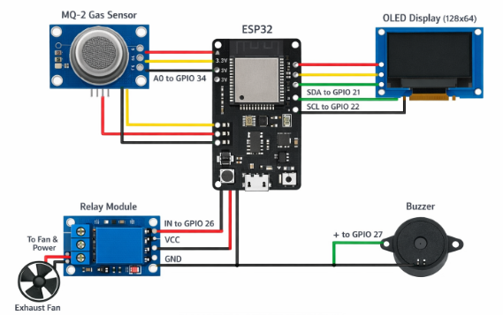
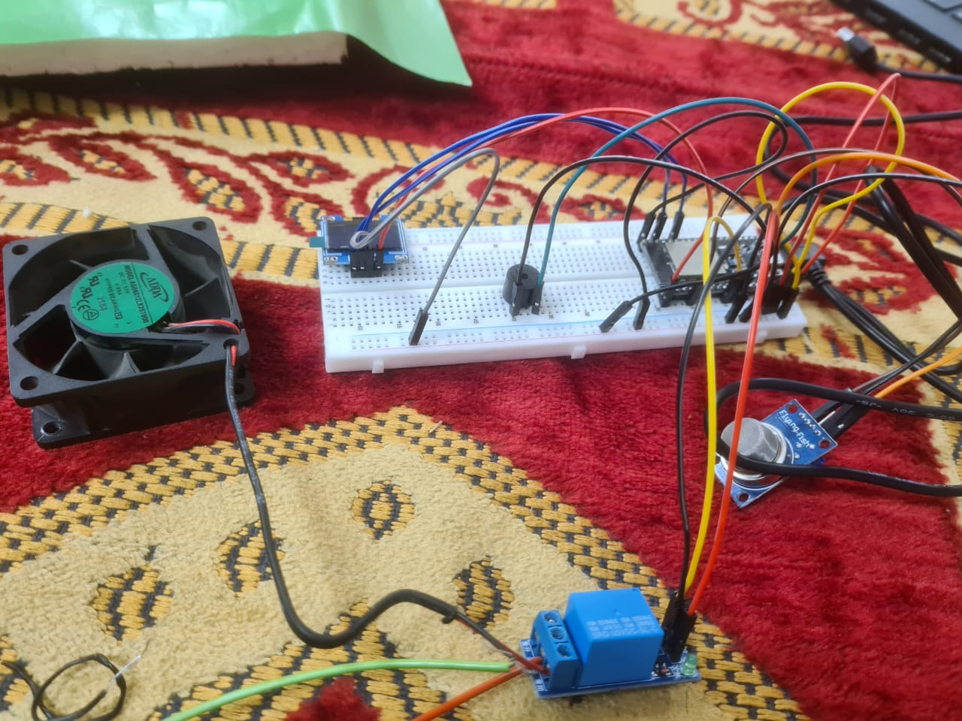

Project Physical Structure:
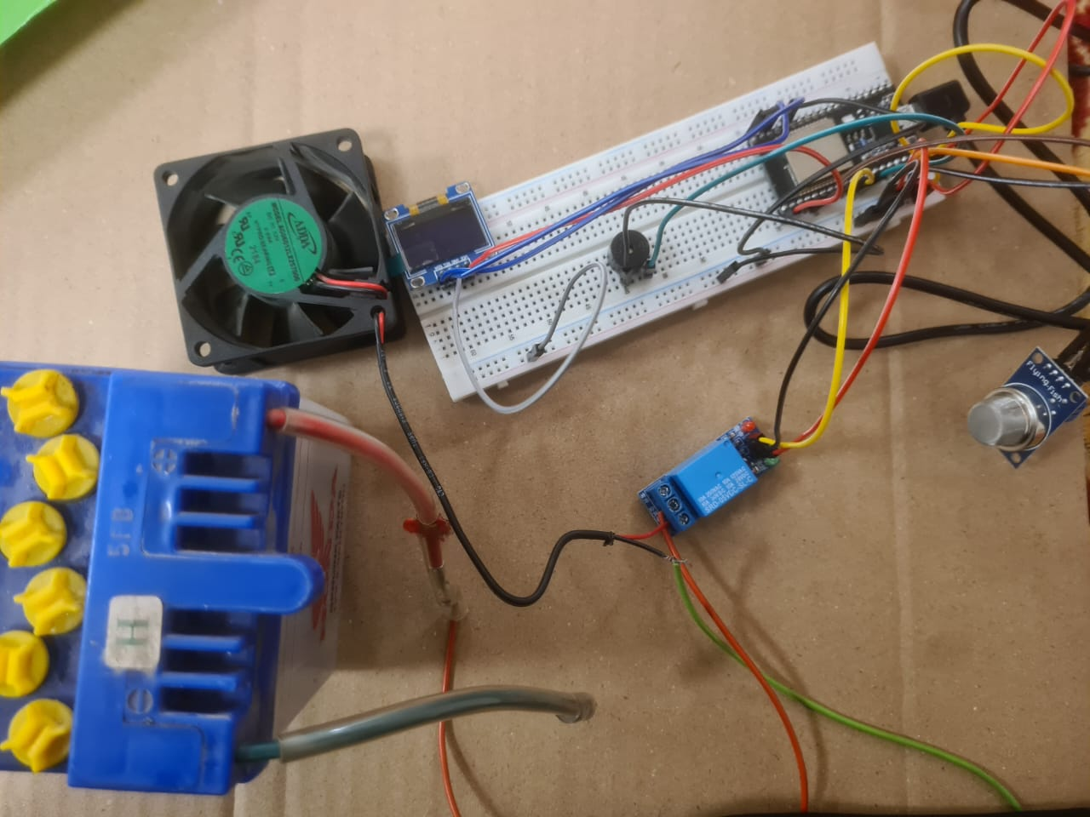
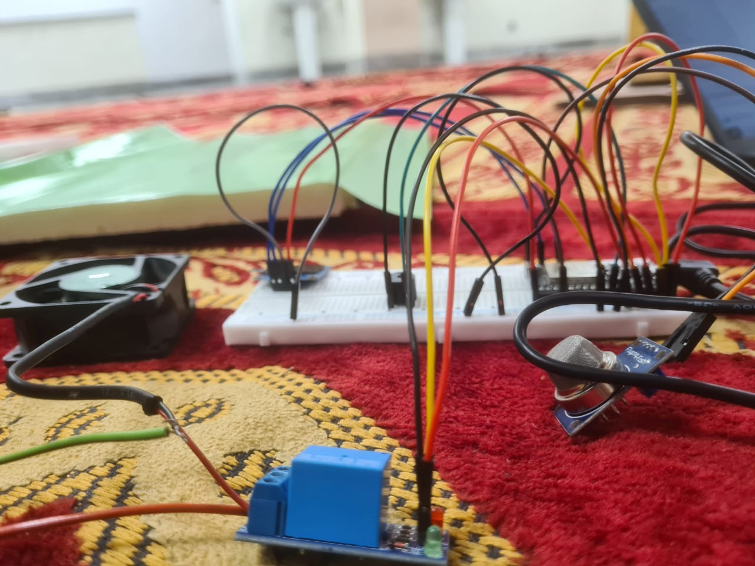

Prototype Design Pictures:

Blynk Notification and Email ScreenShots:

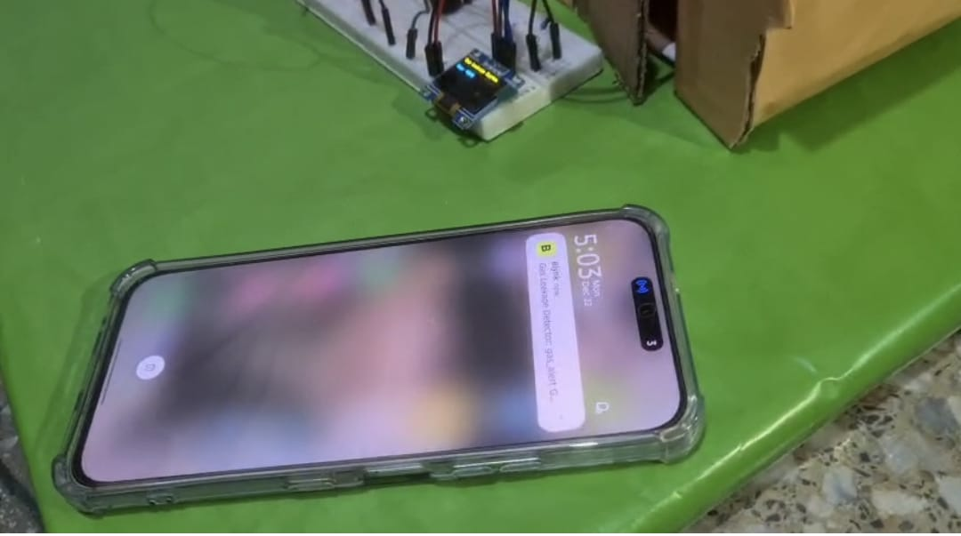

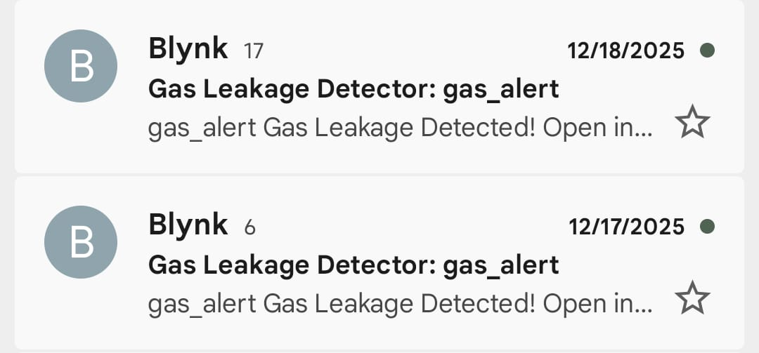
Final Project Design:

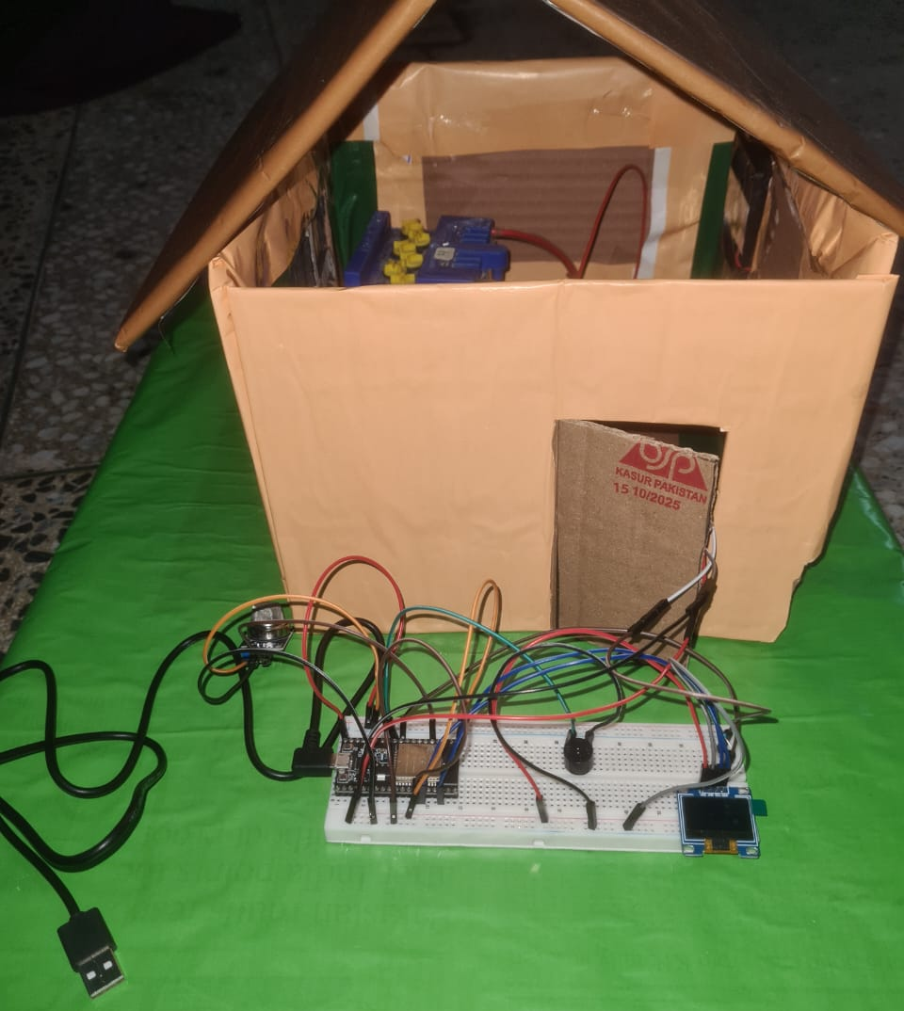

Conclusion:
Our project successfully implements a Gas Leakage Detection System using ESP32 and IoT technology. The system continuously monitors gas levels and provides instant alerts through a buzzer, exhaust fan, OLED display, and Blynk mobile application. It ensures quick response to gas leakage, improving safety and reducing the risk of accidents. The integration of IoT allows remote monitoring, making the system reliable and user-friendly.
Future Scope:
In the future, this system can be enhanced by adding SMS or call alerts using a GSM module for areas without internet access. Data logging and graphical analysis can be implemented using cloud platforms. Additional sensors can be integrated to detect different types of gases. The system can also be expanded with AI-based prediction and automatic emergency shutdown features for advanced safety.

